Aim |  |  |  | 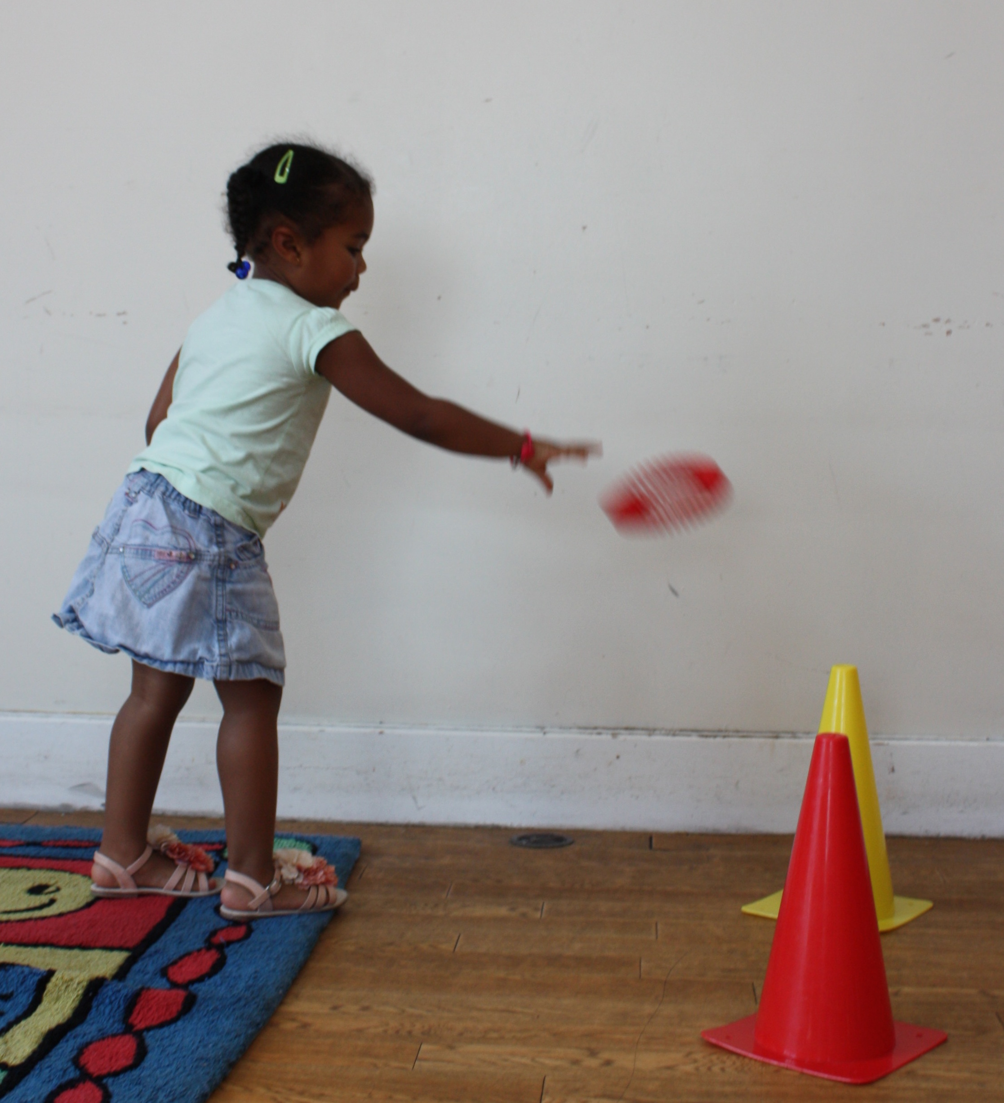
Bounce

Changing Directions |  |  | 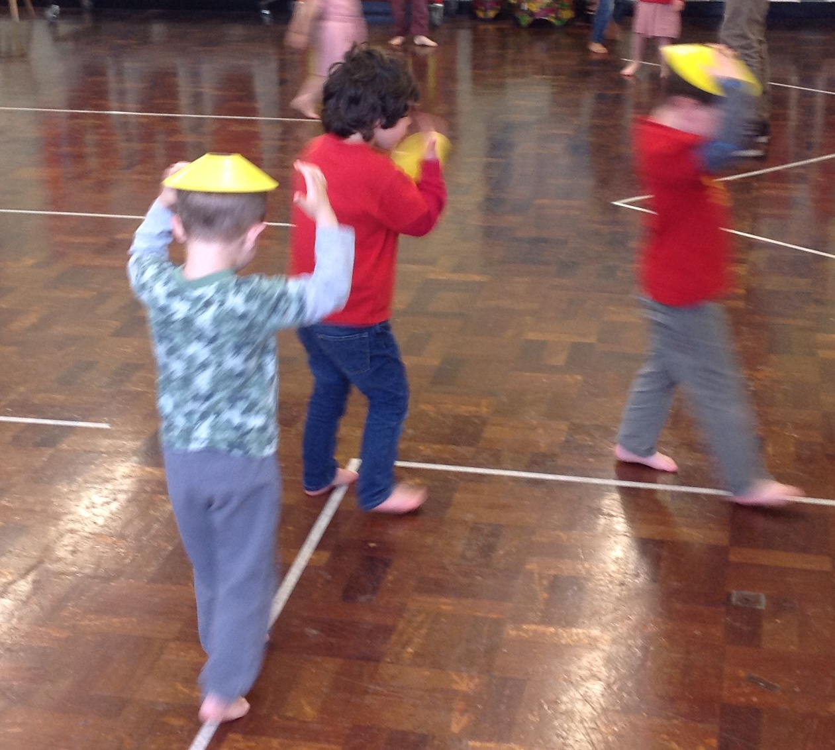
Catch |  |  |  |  |  |  |  |  | 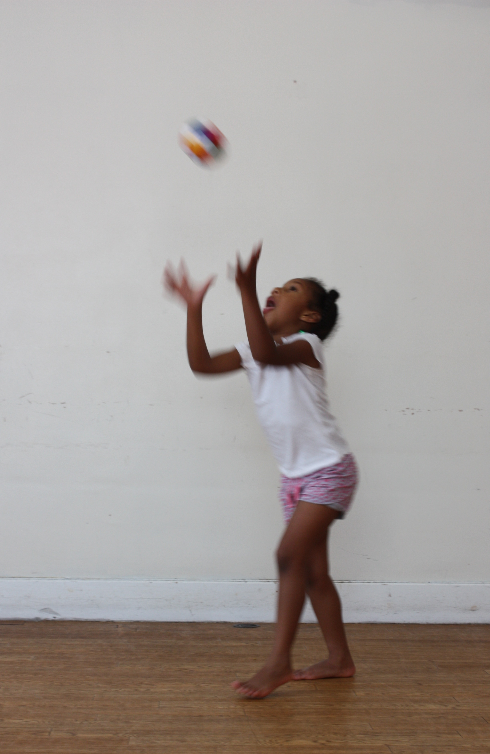
Chase

Combining Movements |  |  |  |  |  | 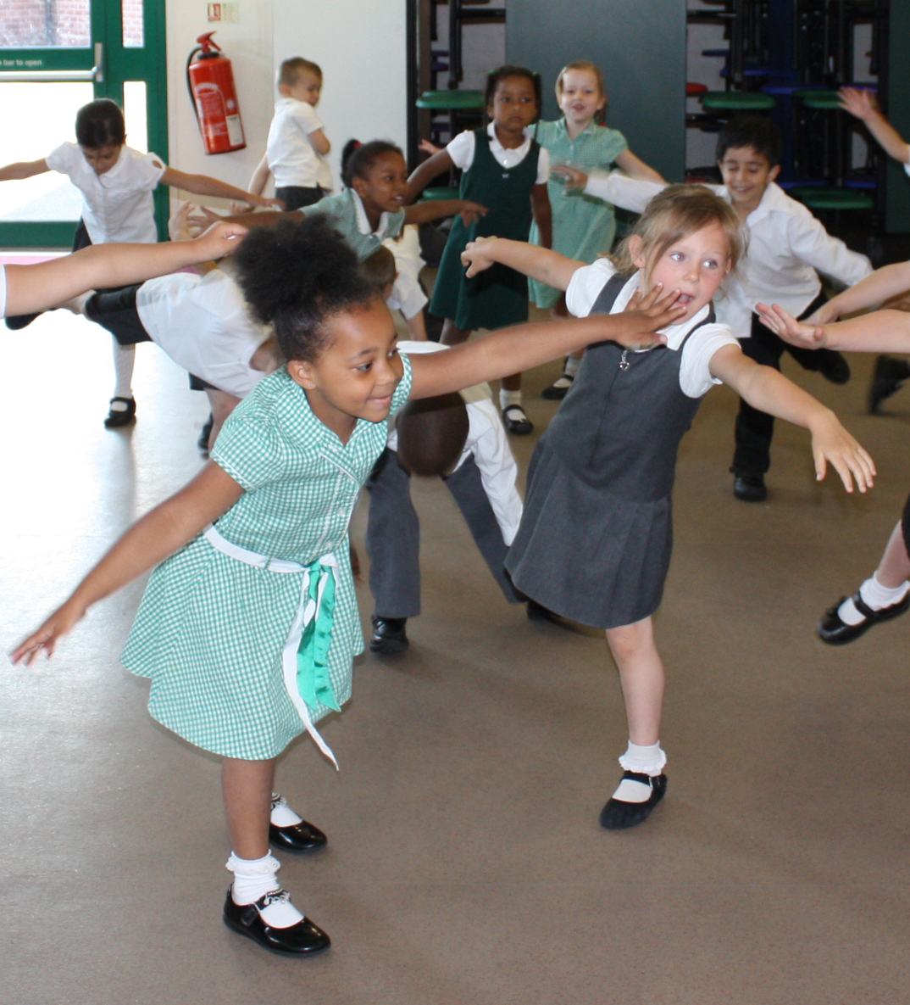
Climb |  | 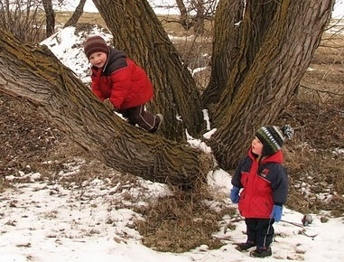
Creep |  | 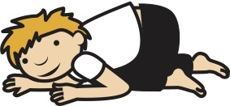
Dance |  |  |  |  |  |  |  |  | 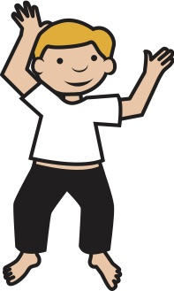
Dig |  |  |  |  |  |  |  |  | 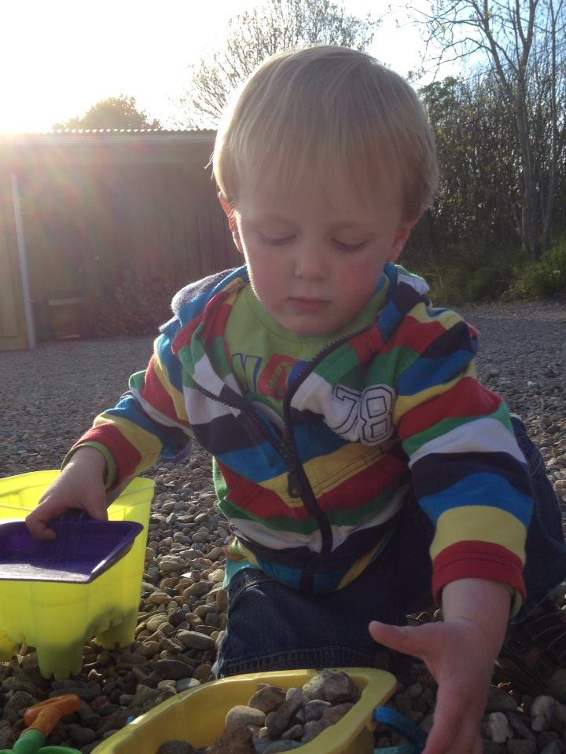
Dodge

Dribble

Evade

Gallop |  |  |  |  |  |  |  |  |  | 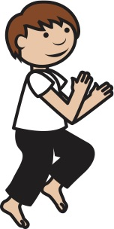
Hang |  |  |  |  |  |  |  | 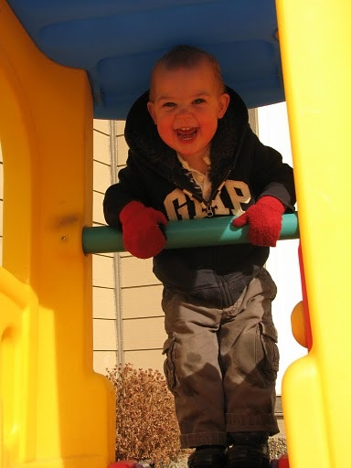
Hit |  |  |  |  |  |  | 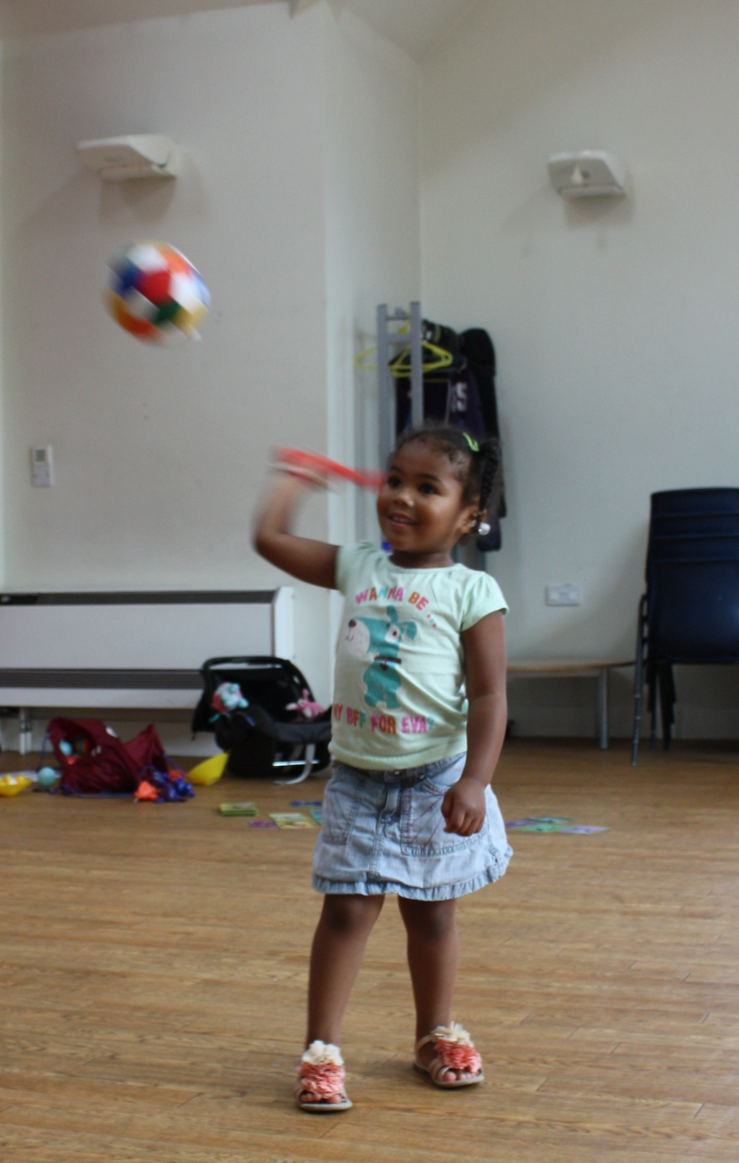
Hop |  |  |  |  |  |  |  |  | 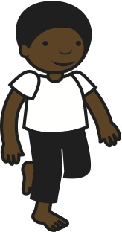
Jump |  |  |  |  |  |  |  |  | 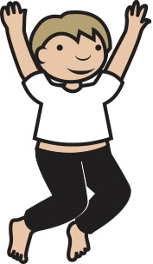
Kick

Land |  |  |  |  |  | 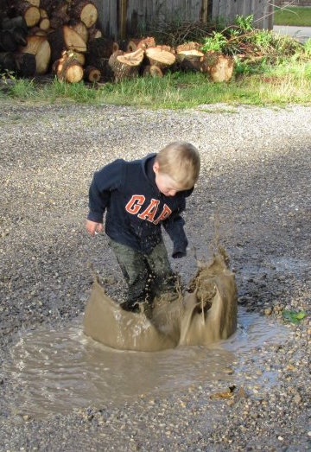
Leap |  |  |  |  |  | 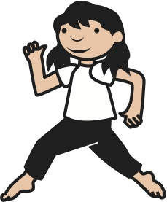
Lift |  |  |  |  |  | 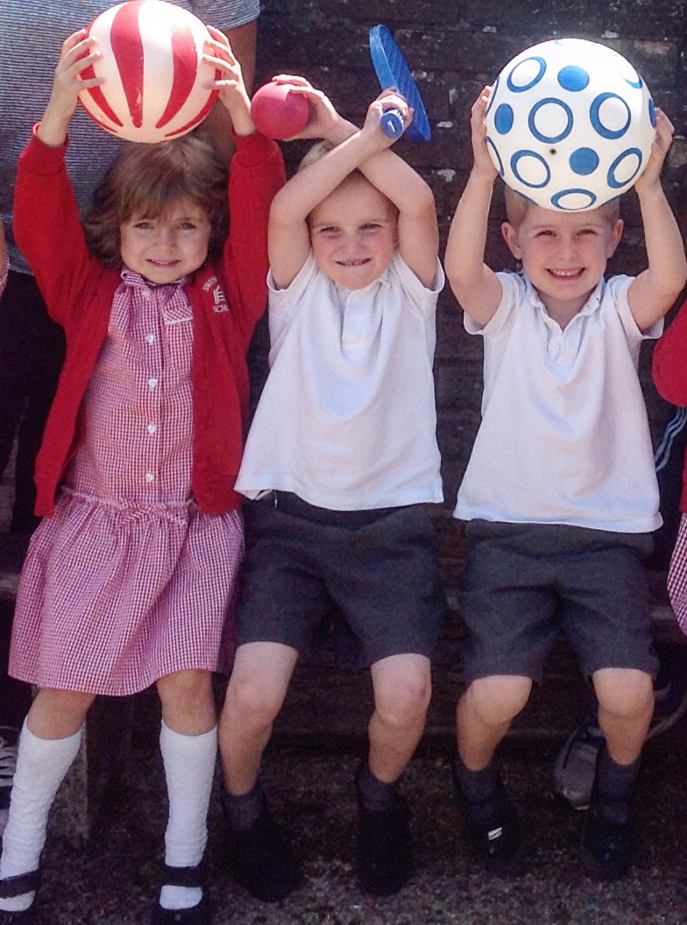
March |  |  |  |  |  |  | 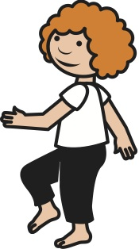
Roll | 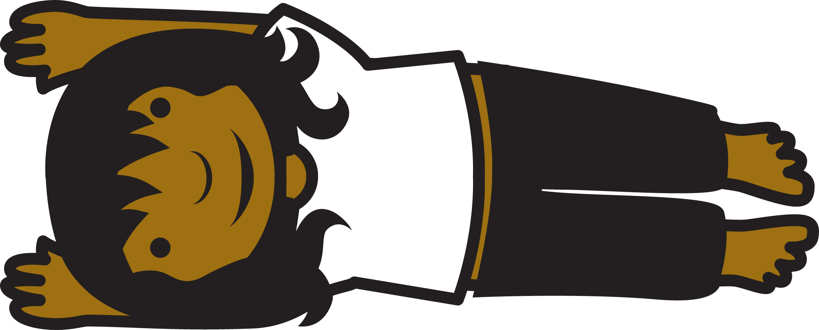
Run |  |  |  |  |  | 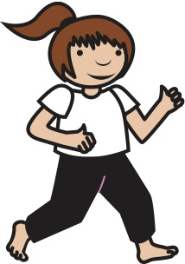
Shuffle

Skip |  |  |  |  |  |  |  |  | 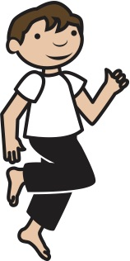
Slide |  |  |  |  |  |  | 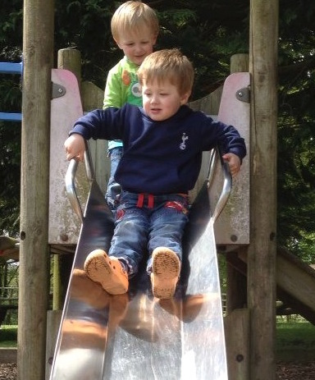
Slither |  |  |  |  | 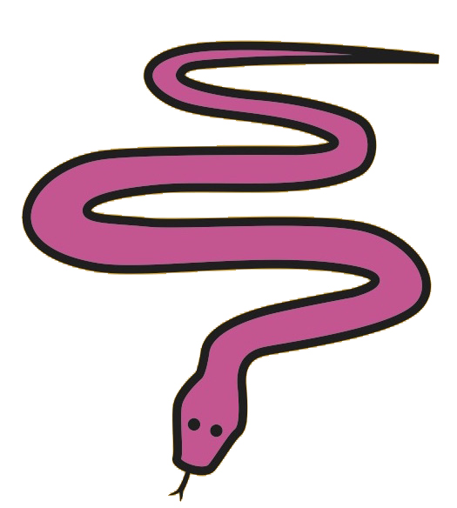
Squat |  |  |  |  |  |  |  |  |  |  |  |  | 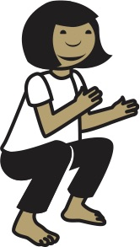
Stack

Strike |  |  |  |  |  | 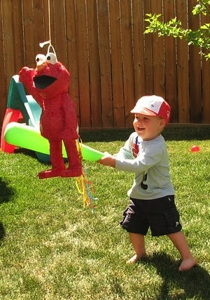
Tap

Throw |  |  |  |  |  |  |  |  |  |  |  | 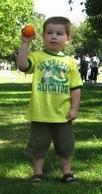
Twist |  |  |  |  |  |  |  |  |  |  | 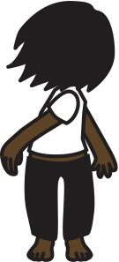
Volley

