 | Aim |  |  |  |  | 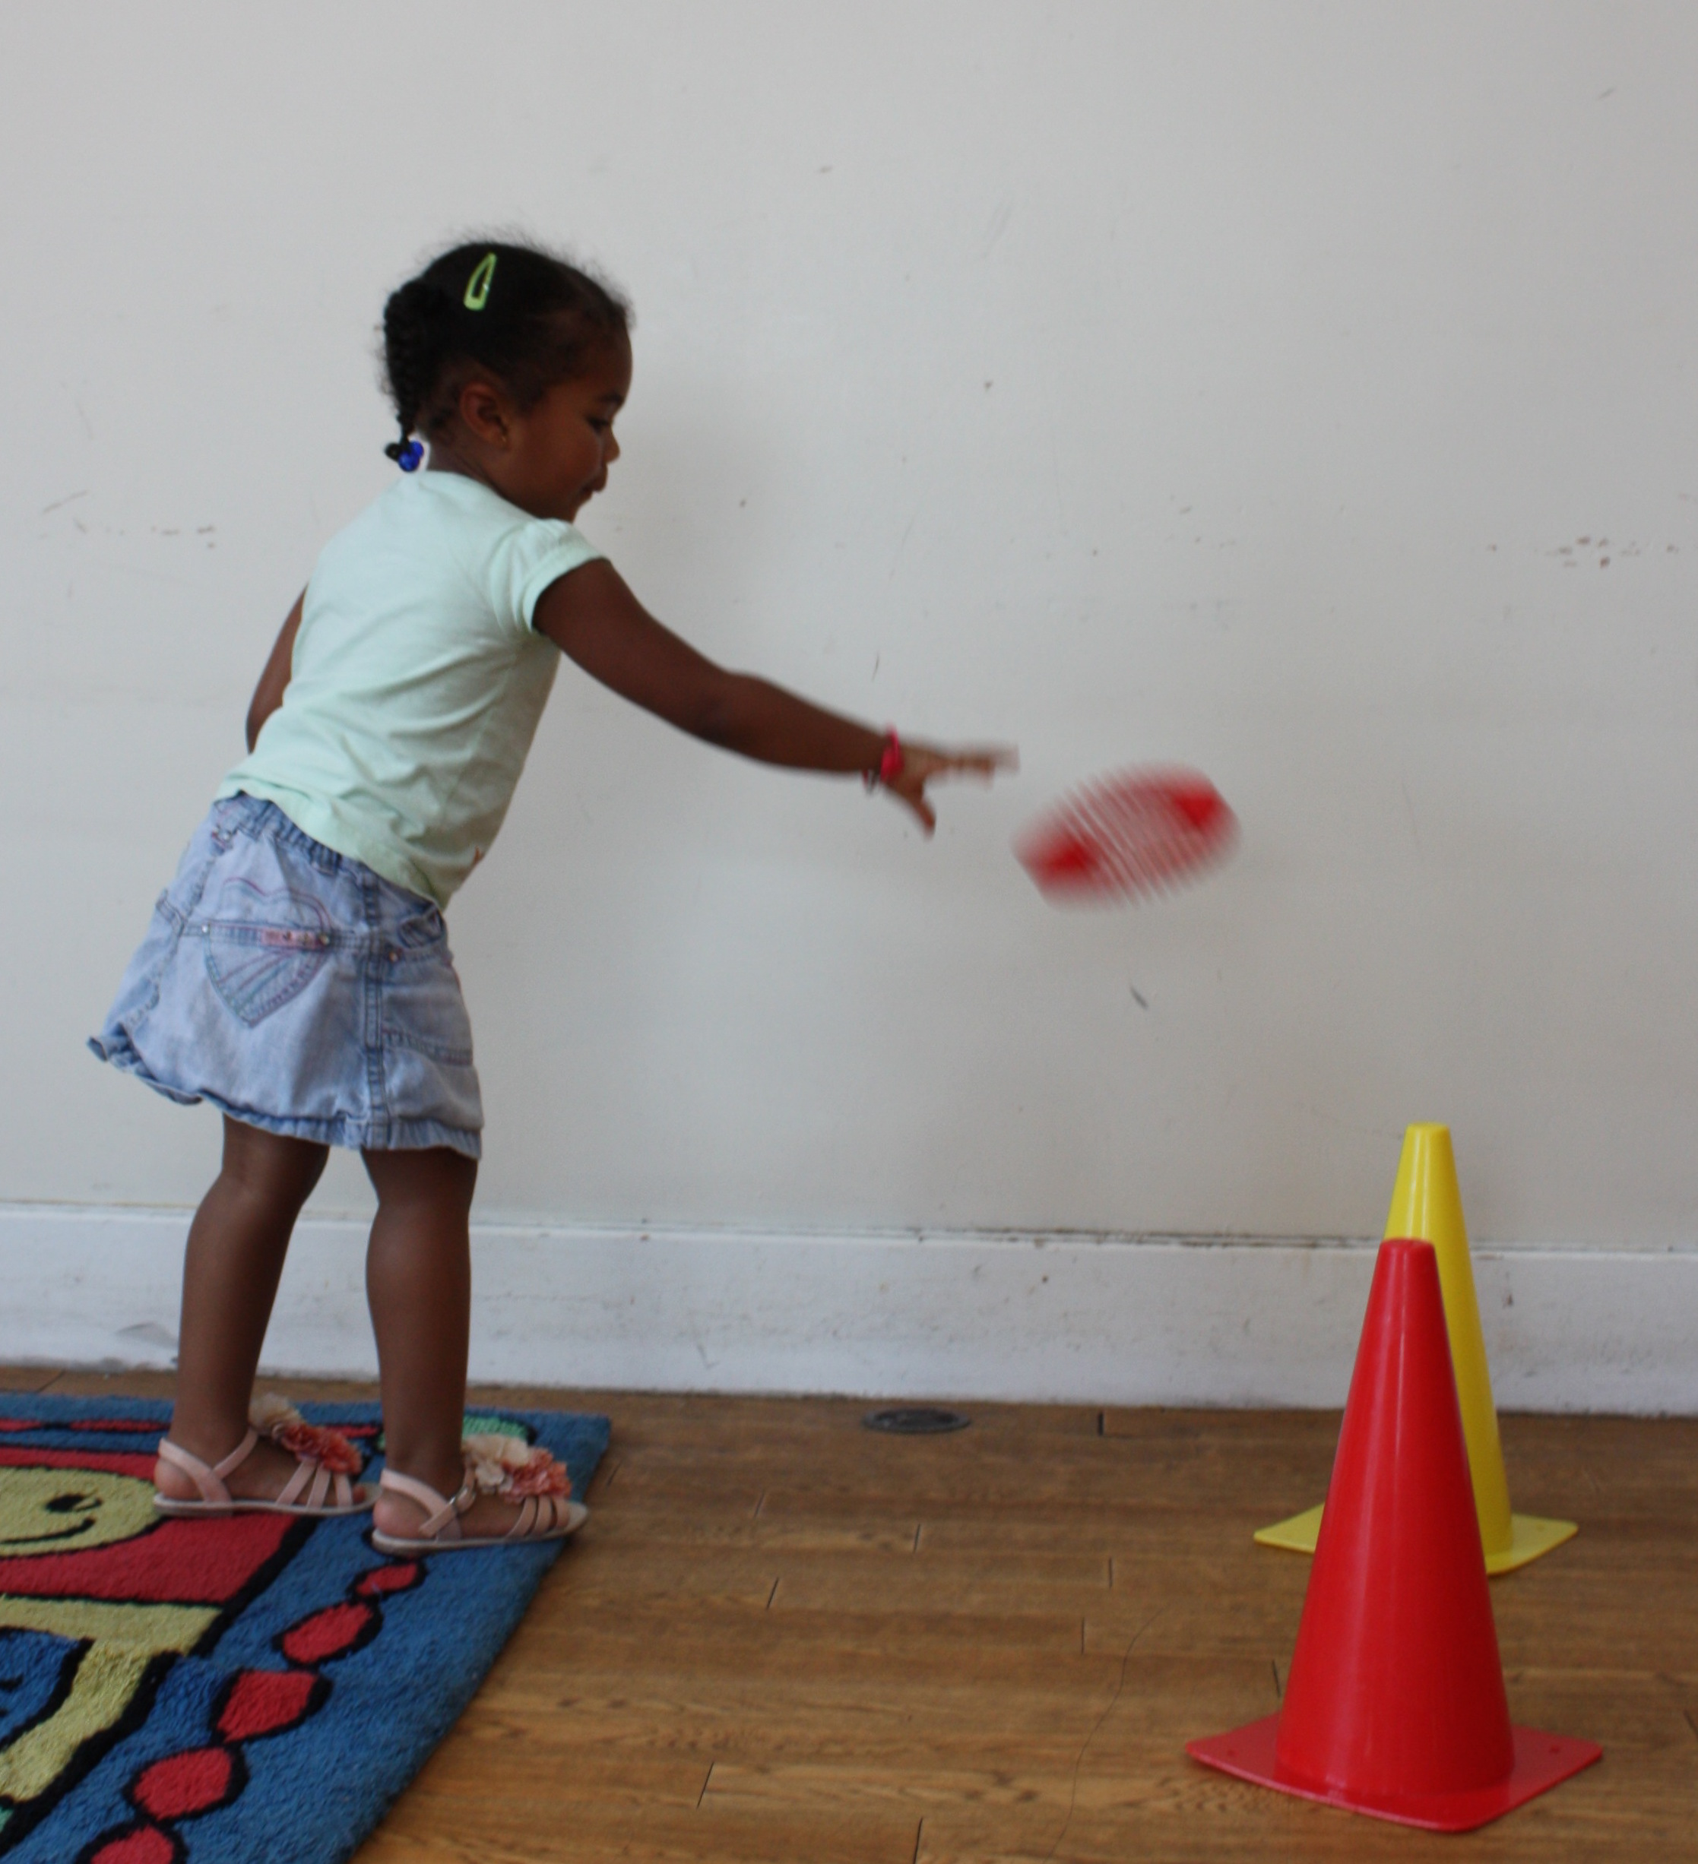
Bounce
 | Catch |  |  |  |  |  |  | 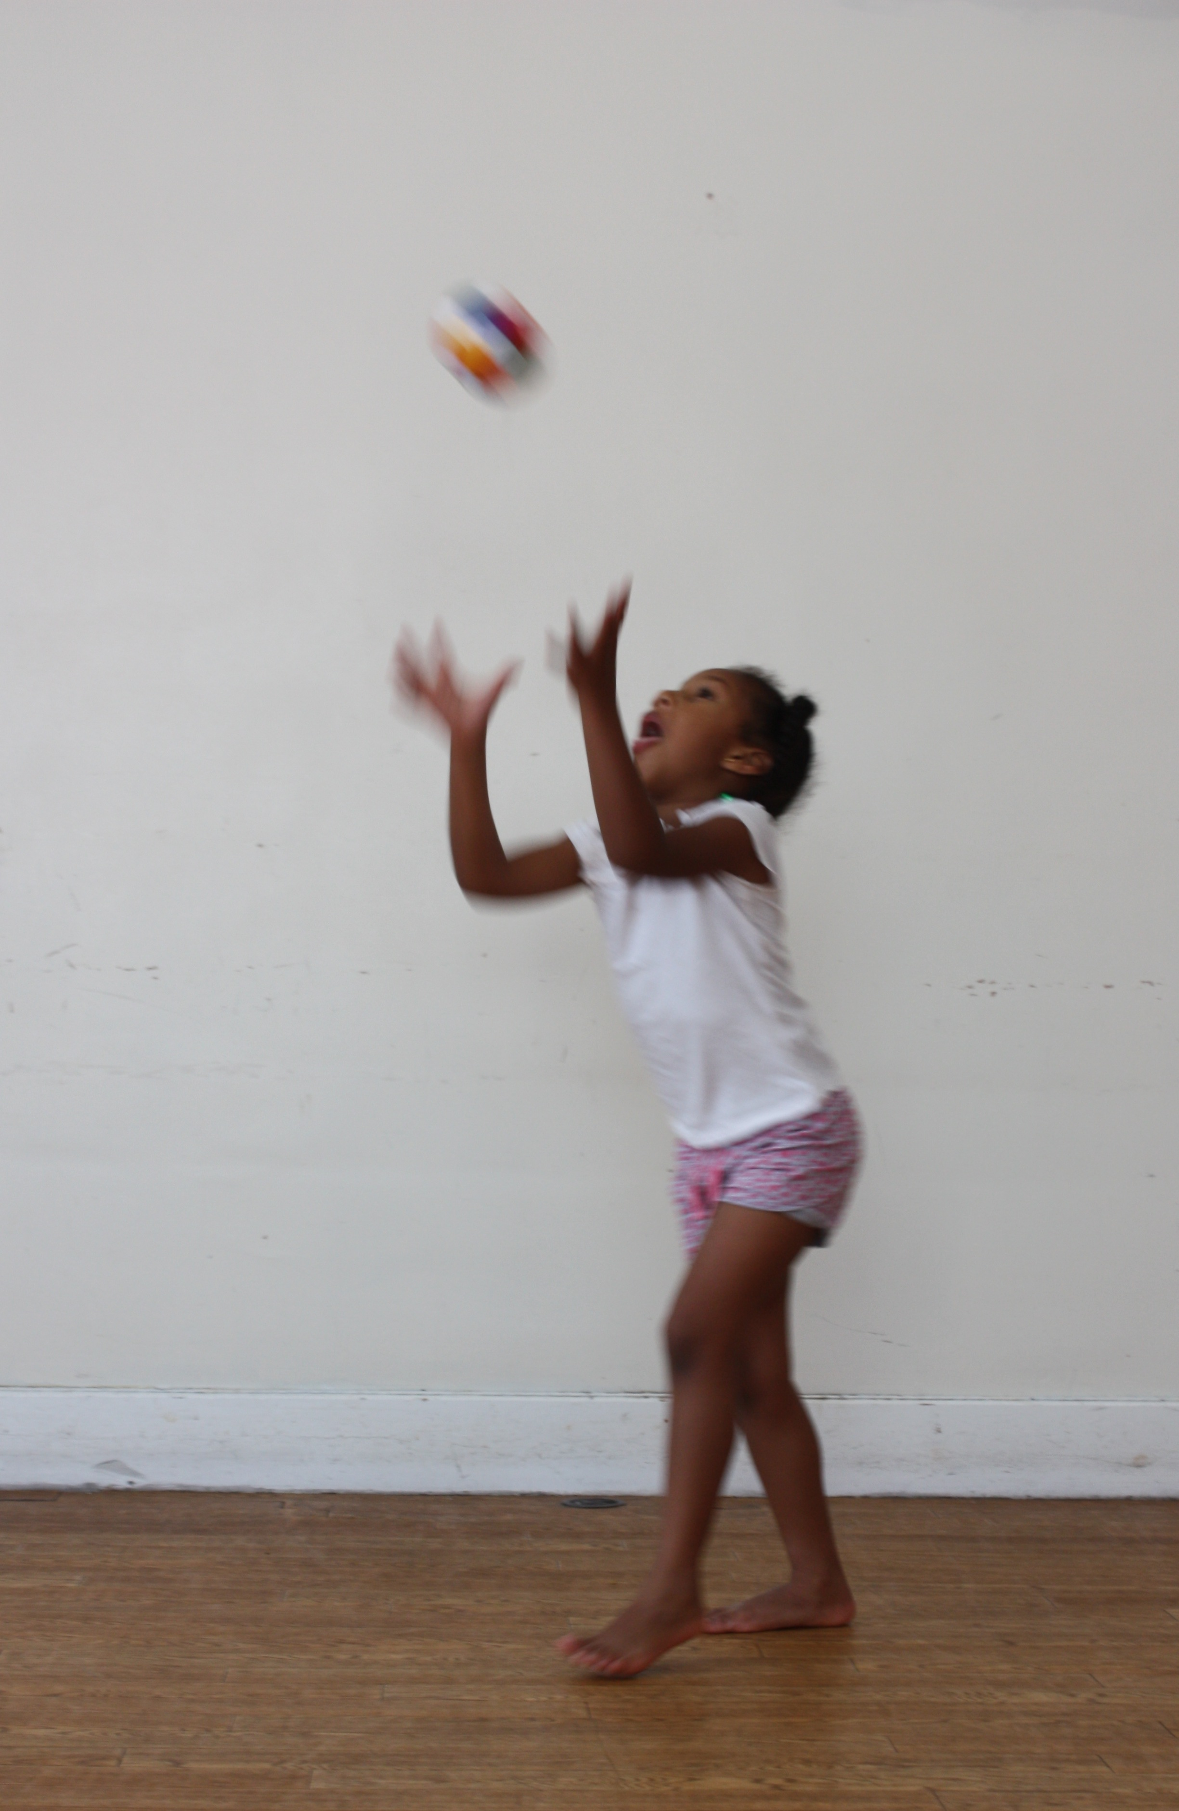
Changing Directions |  |  |  | 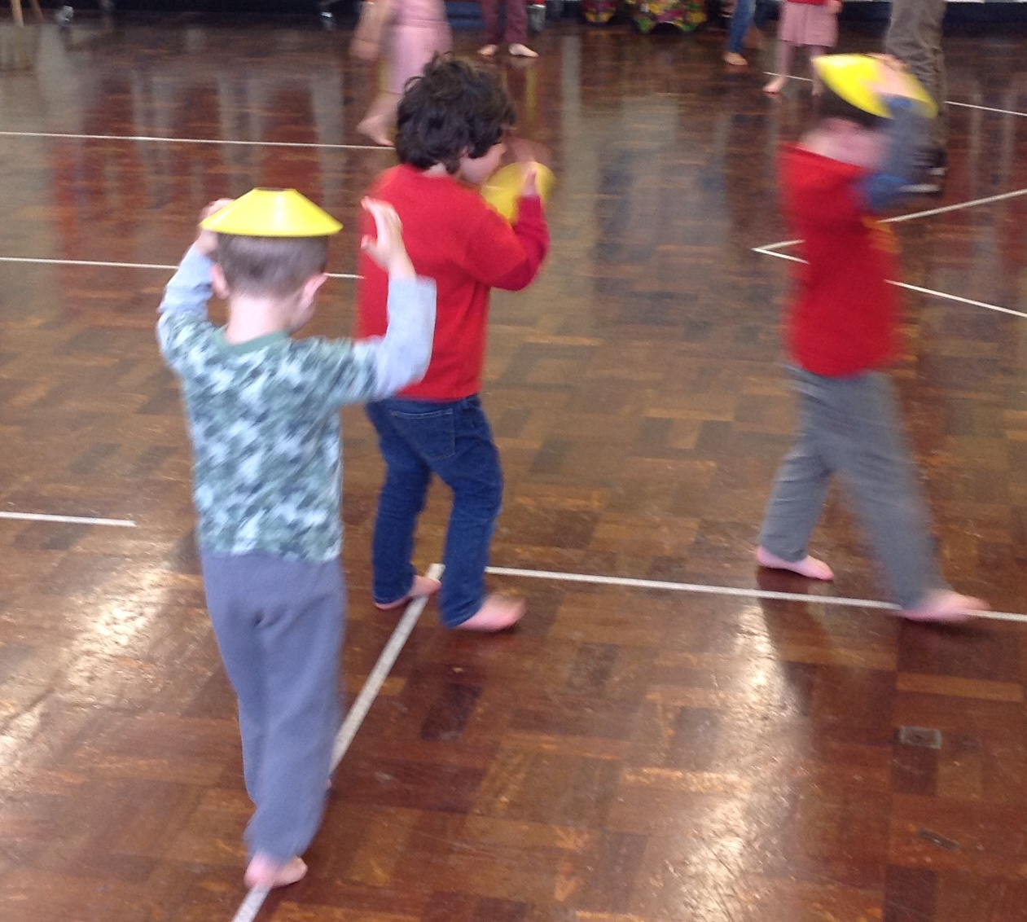
 | Climb |  |  |  |  |  |  | 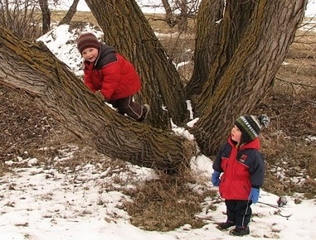
Combining Movements |  |  |  |  |  |  |  | 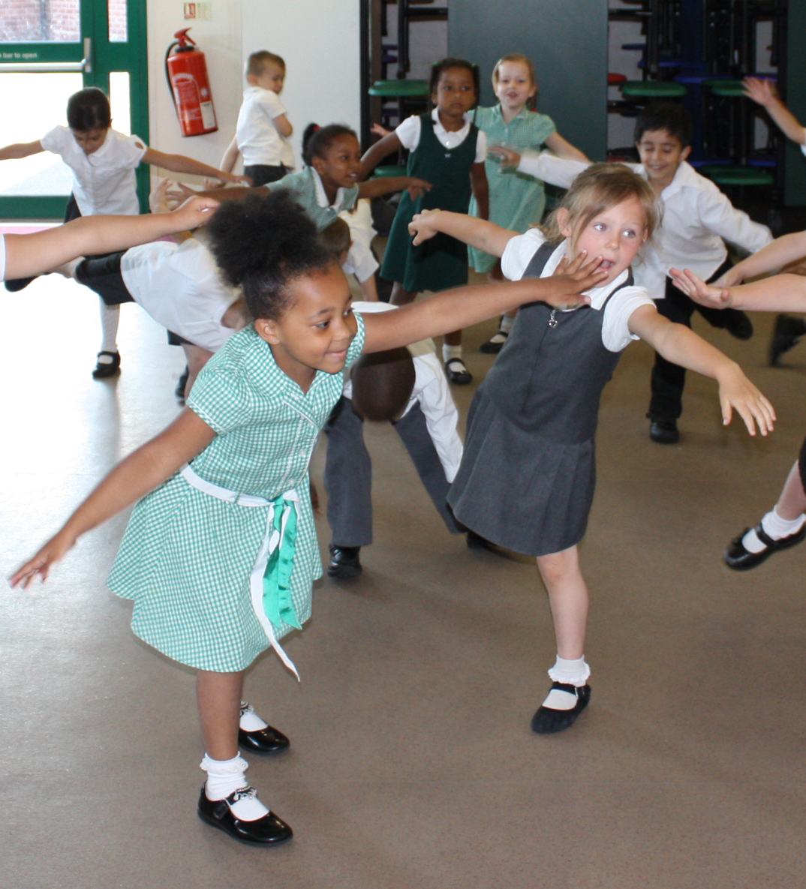
 | Dance |  |  |  |  |  |  | 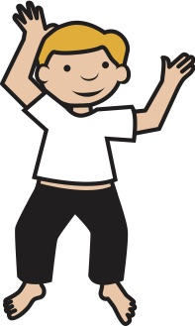
Dodge

Dribble |  |  |  |  |  |  | 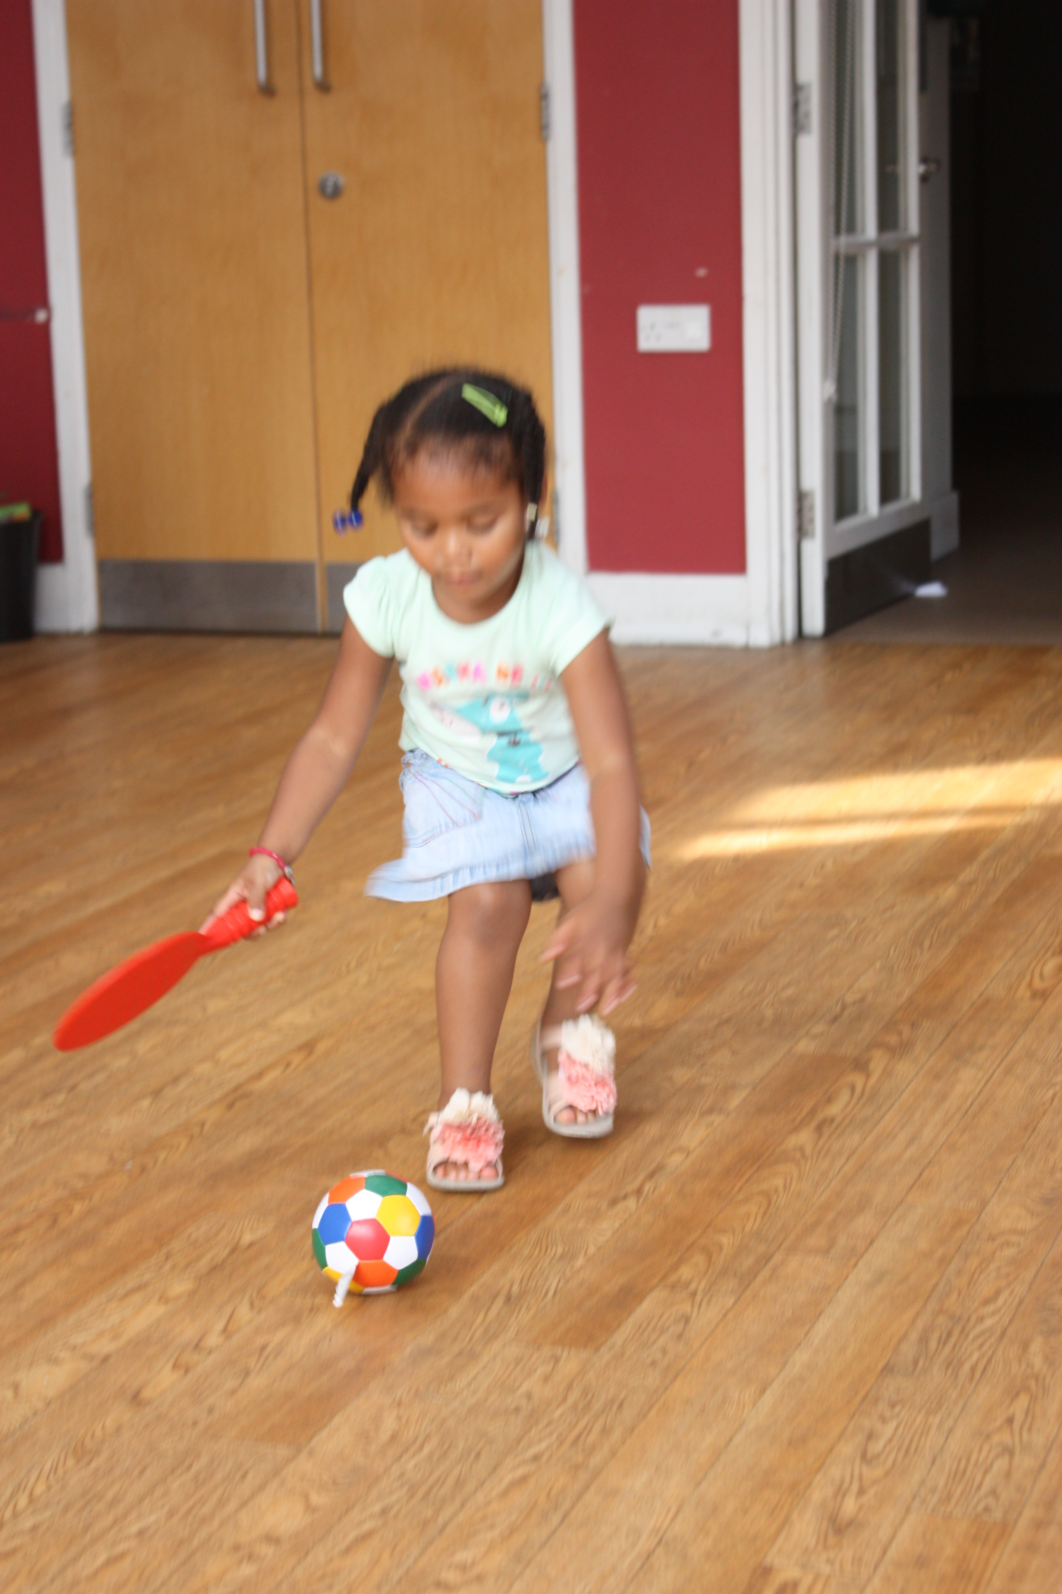
Evade

Flick

Hang |  |  |  |  |  |  |  | 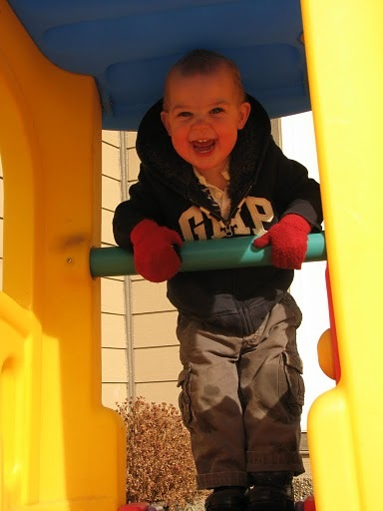
Hit |  |  |  |  |  |  |  | 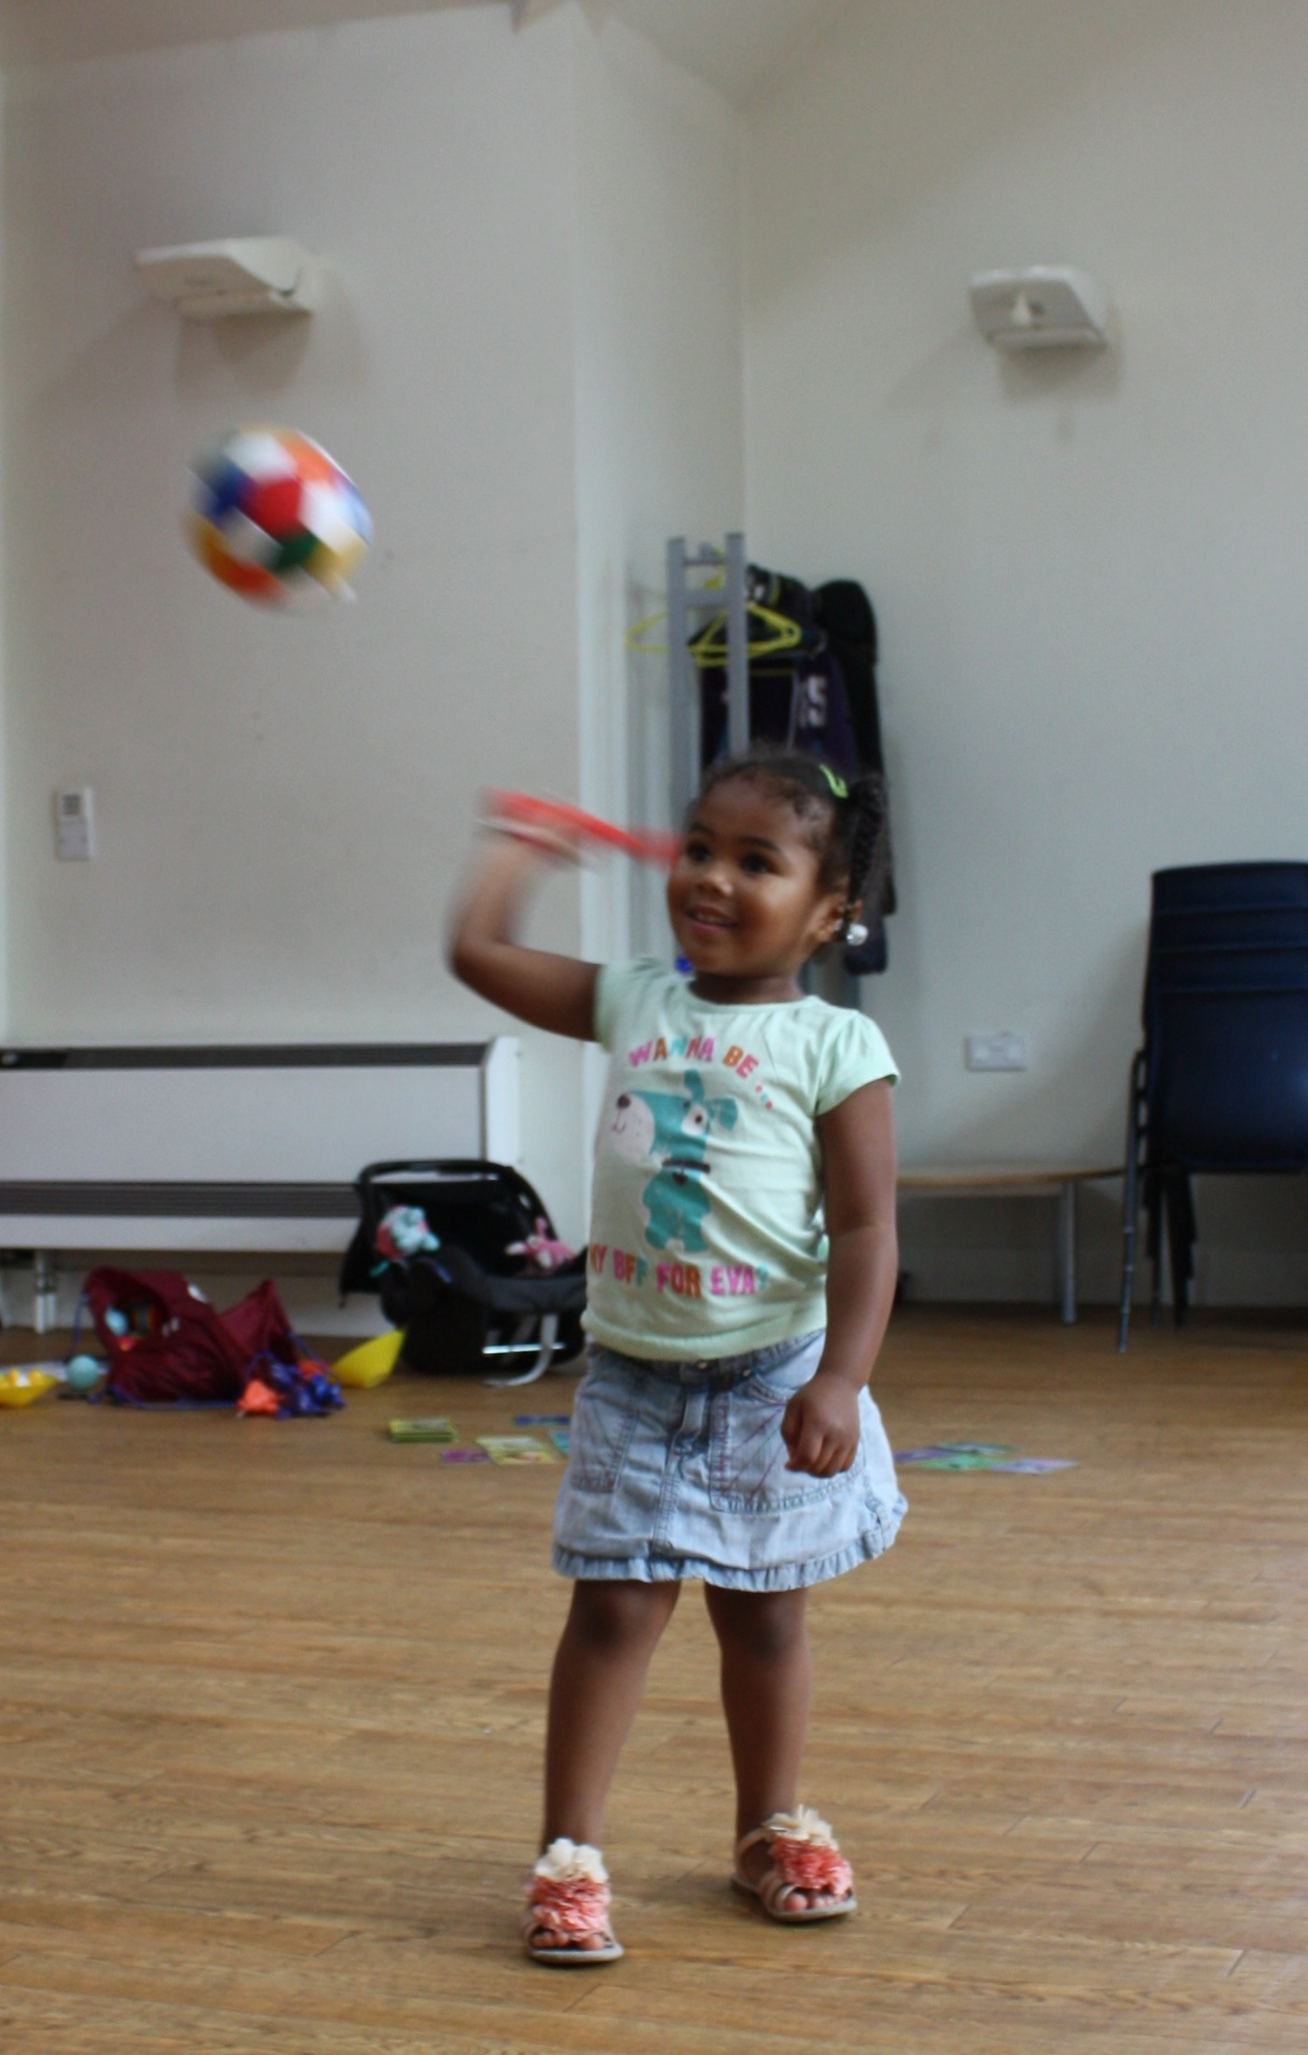
Hop |  |  |  |  |  |  |  |  | 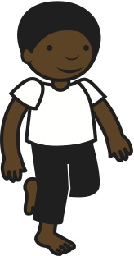
 | Jump |  |  |  |  |  |  | 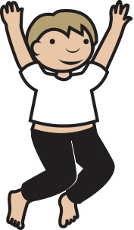
Kick

 | Lunge |  |  |  |  |  |  | 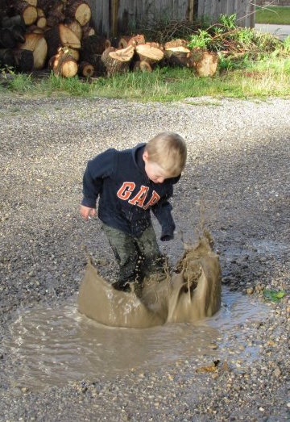
 | Pick Up |  |  |  |  |  |  | 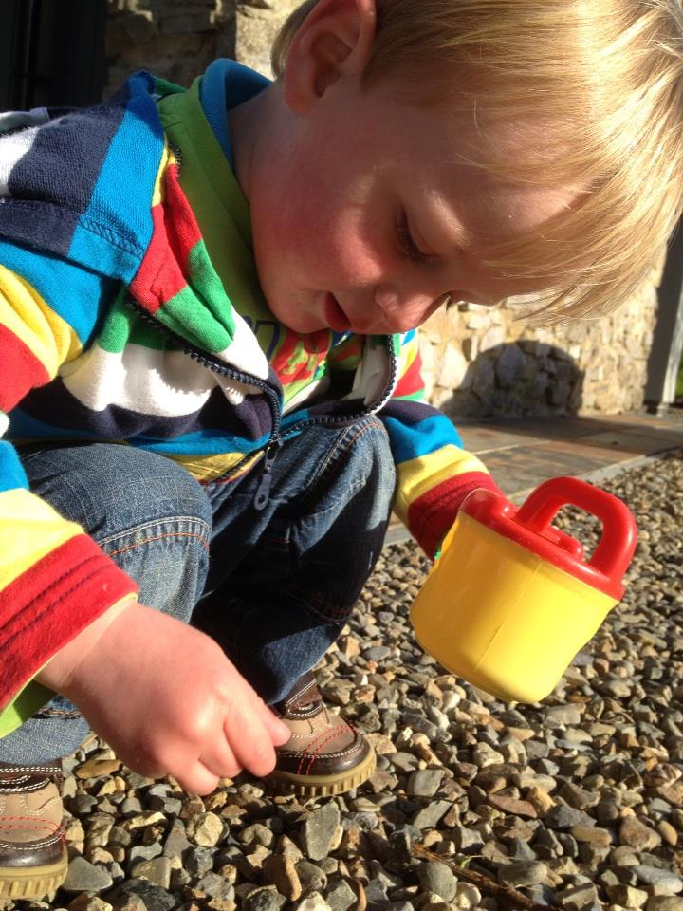
 | Pivot
 | Receive
 | Roll |  |  | 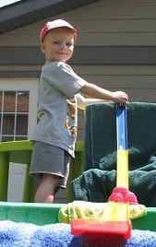
Roll |  | 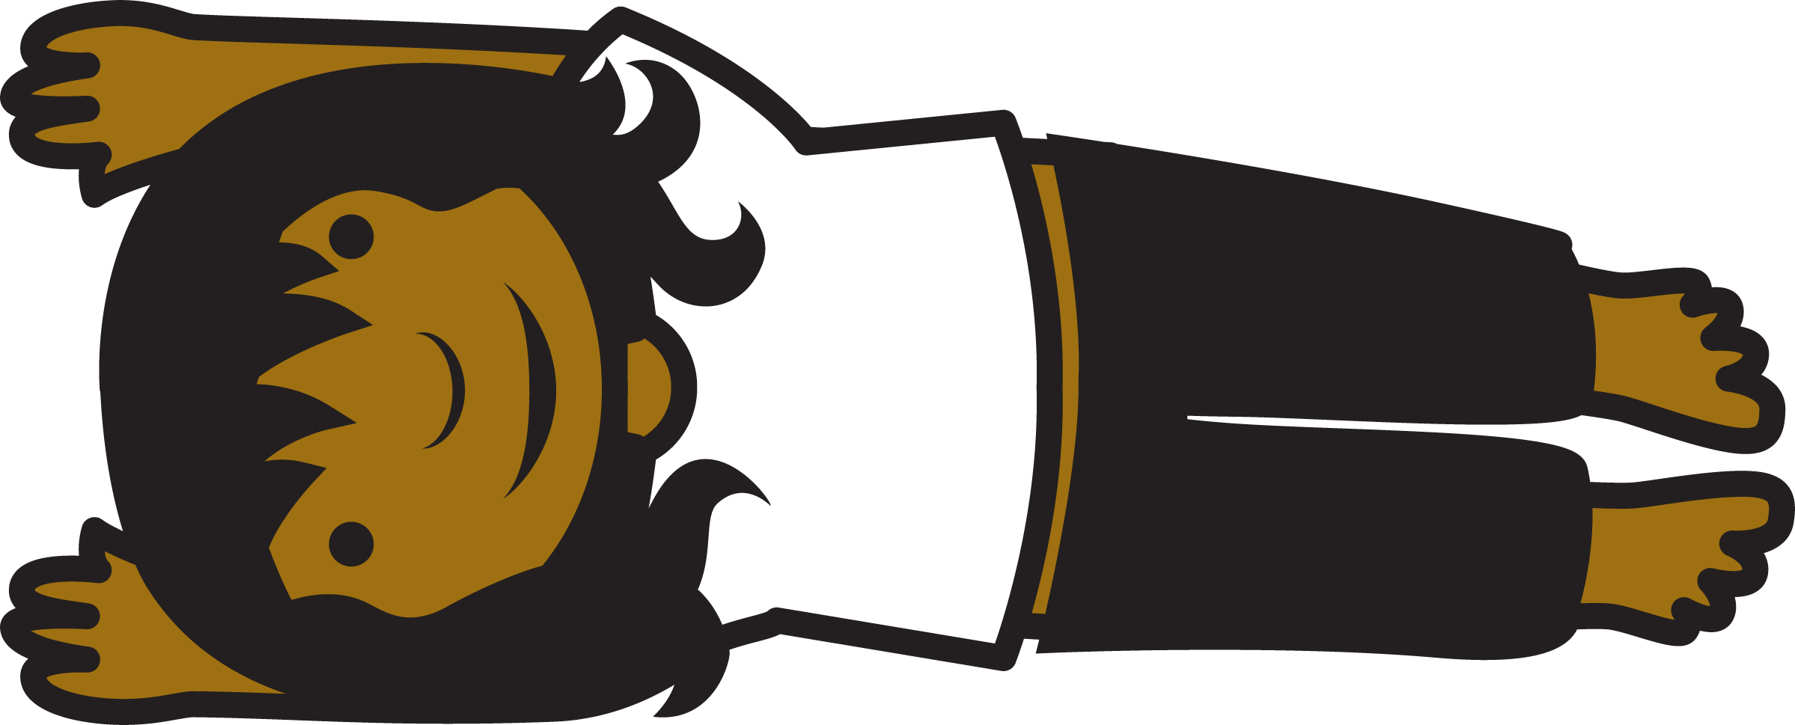
Rotate

 | Run |  |  | 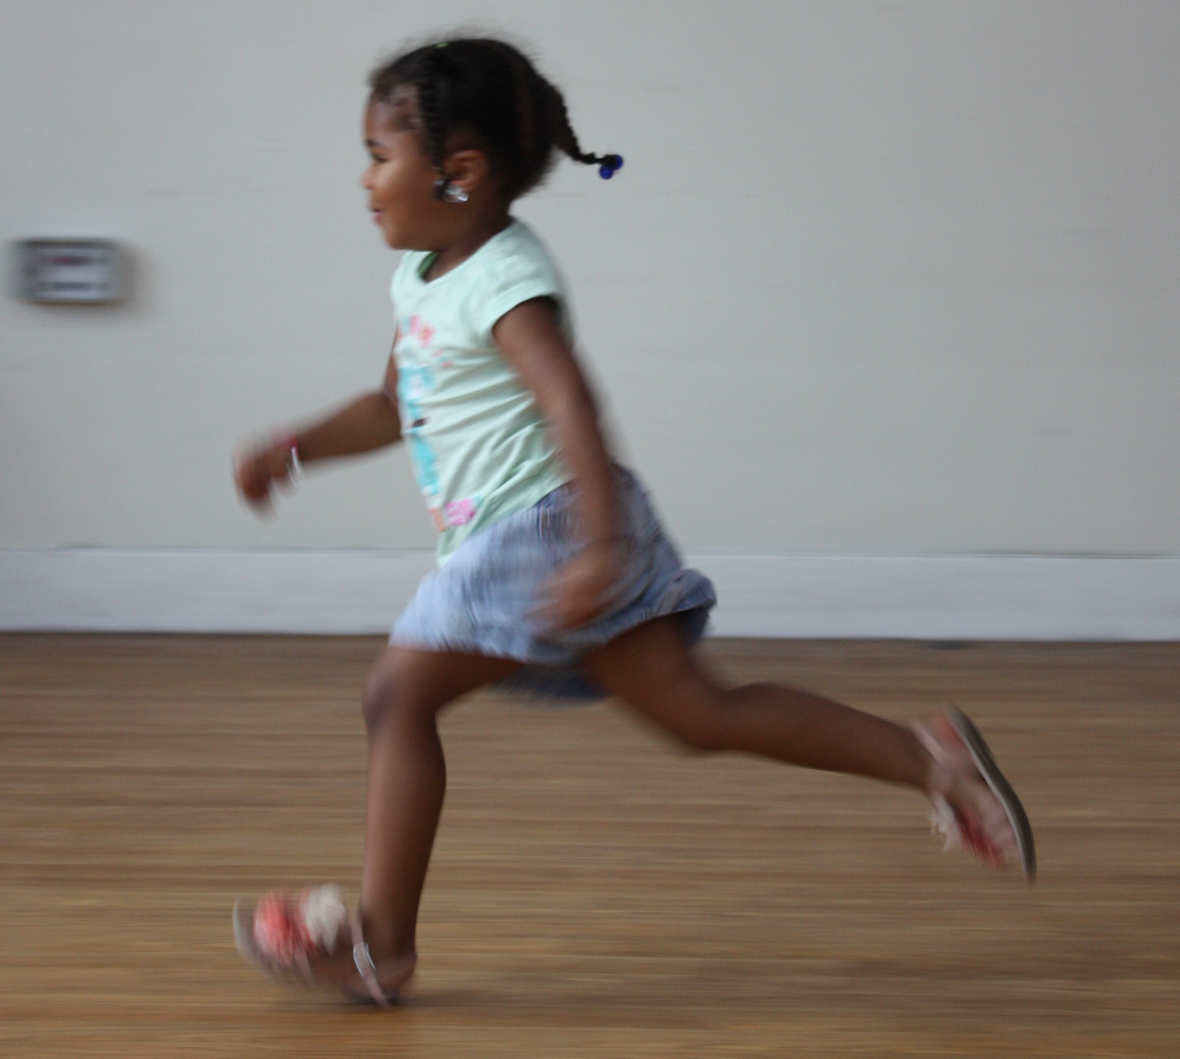
Score
Shoot

Skip |  |  |  |  |  |  |  |  |  | 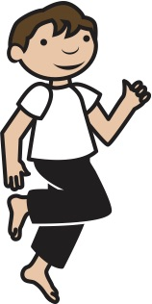
 | Spin |  |  |  |  |  | 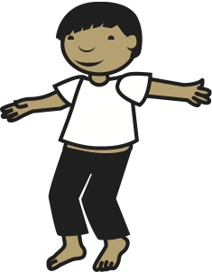
Strike |  |  |  |  |  |  |  | 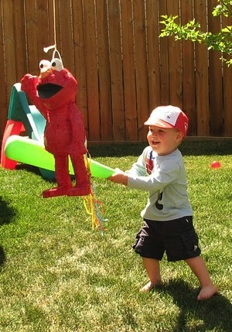
Throw |  |  |  |  |  |  |  | 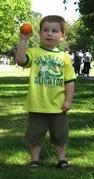
Volley

 | Walk |  |  |  |  |  |  | 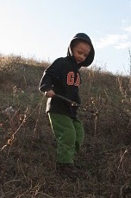
 | Wave
 | Wiggle |  |  |  | 